Deep Learning using Neural Networks

[Bagging v/s boosting](https://www.kaggle.com/code/prashant111/bagging-vs-boosting)

Machine learning is a way of training machines with data and mathematical model so that they can learn to automate certain tasks without human intervention.

Machine learning is a subset of Artificial Intelligence and so is Deep Learning of Machine learning. Building Mathematical Models for calculating outcomes is not new but it gained significant momentum in early 21st century due to big data. Industries needed predictive models which could be used to predict enormous amount of data of the customers. Since then many real world applications of Machine learning have been developing. Machine learning has significantly transformed the field of Medical Science, Finance, Business, Environmental Science, etc. Machine Learning technologies like Neural Networks, Large Language Models, Computer Vision, etc.

Deep Learning is a field of machine learning which provides solutions by using Neural Networks so in this article let’s try and understand how the neural networks work:

As the name suggest the neural network term is adopted from network of neurons in the human brain. It was named so cause at the beginning the neural networks were type of models which were developed to mimic the function of human brain

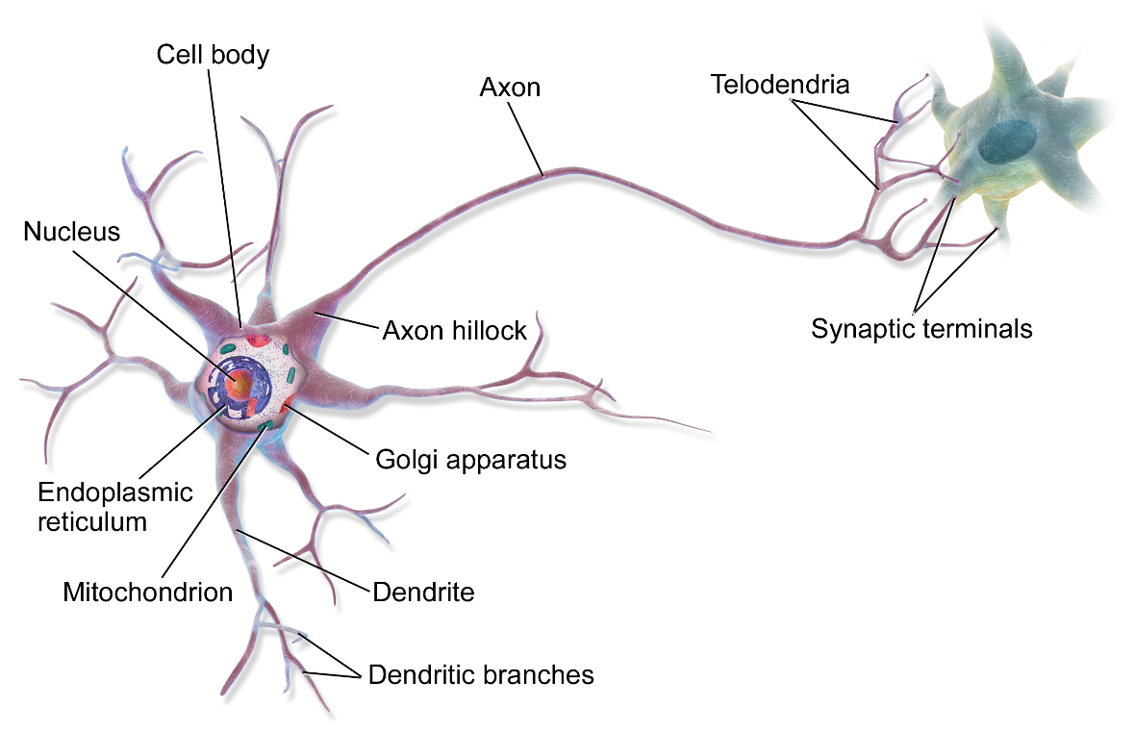

Just like biological neurons with multiple axons taking inputs from multiple neurons to process the data and then generate an output signal which acts like an input to other neuron. Just like this Neurons in neural network take input from multiple neurons and generate an input signal for other neurons. Although at start the main goal behind development of neural network based machine learning models was to mimic human brain but it has become pretty evident that we as humans don’t really know how brain works so the applications of neural networks increased rapidly to solve real world problems rather than mimicking the biological brain.

Before Understanding how neural ntworks work let’s try and understand how data flows through machine learning model and predicts and outcome;

Ex) Linear Regression:

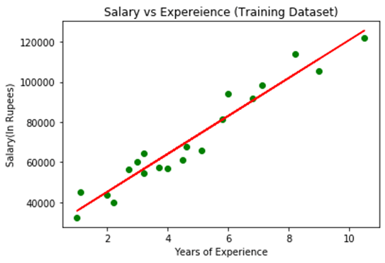

Linear regression is a ML Model which takes No of features in a data set as a input and try to fit and linear curve (Straight Line) Through those data points using optimization function (ex. GDA algorithm). So when a new values of input is given output can be predicted. This is done by properly determining weights of different features in the given curve

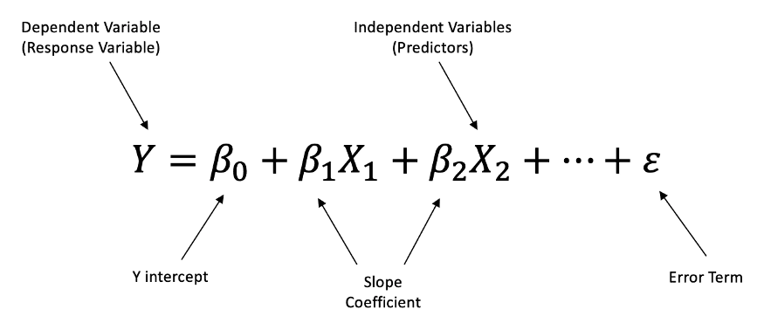

Neural networks are made up of n Numbers of hidden layers consisting of M numbers of neurons where each neuron is fed with data which is evaluated using activation function. Activation functions are mathematical formulas which generate output for each neuron also called as activation value (values on scale of 0-1). If a layer consists of m neurons, then activation values of M such neurons act as a input Vector for Other Layer in the Neural Network.